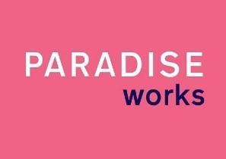
Equal Opportunities Form
Paradise Works is committed to equal opportunities in all aspects of its work. Information provided here is confidentially held and is used for monitoring purposes only. The information you share is voluntary and is separate to your application, it will not be used in the assessment process. Thank you.

Please select which age group you belong to: |  | 18-29
 |  | 30-39
 |  | 40-49
 |  | 50-59
 |  | 60+
 |  | Prefer not to say
What best describes your gender? |  | Female
 |  | Male
 |  | Non-binary
 |  | Other:_______________
 |  | Prefer not to say
What best describes your sexual orientation? |  | Bisexual
 |  | Gay man
 |  | Gay woman / lesbian
 |  | Heterosexual / straight
 |  | Other:_______________
 |  | Prefer not to say
What best describes your ethnicity? |  | Arab
 |  | Asian or Asian British: Indian
 |  | Asian or Asian British: Pakistani
 |  | Asian or Asian British: Bangladeshi
 |  | Asian or Asian British: Chinese
 |  | Asian or Asian British: Other Asian background
 |  | Black or Black British: African
 |  | Black or Black British: Caribbean
 |  | Black or Black British: Other Black background
 |  | Mixed: White and Black Caribbean
 |  | Mixed: White and Black African
 |  | Mixed: White and Asian
 |  | Mixed: Other Mixed background
 |  | White: British
 |  | White: Irish
 |  | White: Gypsy or Traveller
 |  | White: Other
If any other ethnic group or you prefer your own definition please specify:
____________________________
 |  | Prefer not to say
Do you consider yourself to have a disability? |  | Yes
 |  | No
 |  | Prefer not to say

