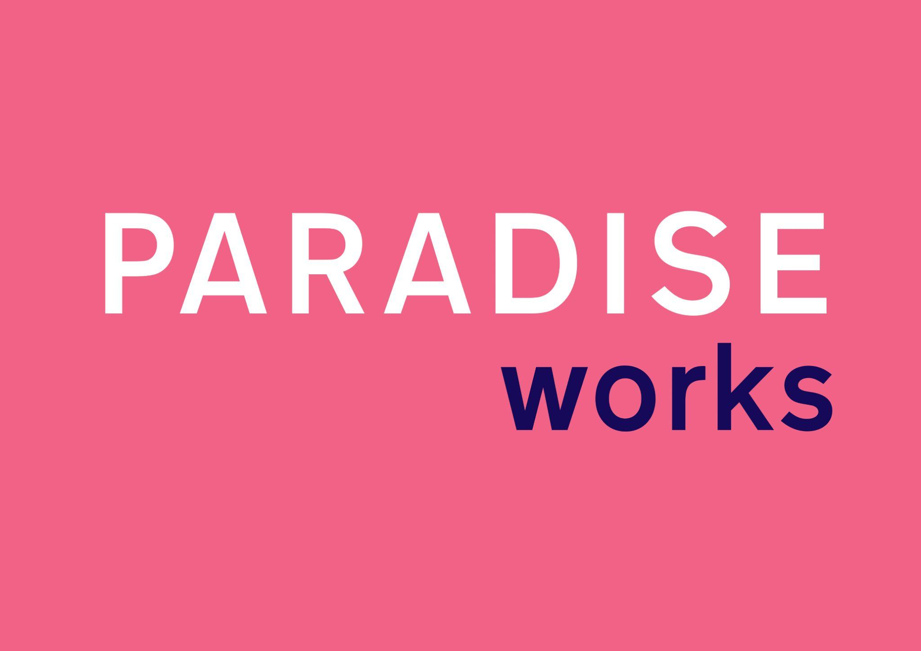

Company Reg. No.: 10640282
Paradise Works
East Phillip St, Salford
Greater Manchester
M3 7LE
PARADISE WORKS 2024 RESIDENCY APPLICATION
Please fill this form to apply for the residency programme. Deadline: Sunday 25th February. If you have any questions regarding the Residency, please refer to our residency call out or email info@paradise-works.com

Name:
Email Address:
Website (if applicable):
Instagram (if applicable):
Address:
Date of Birth:
Nationality:
Phone number:

Dates:
Please tell us when you would like the residency to take place, by numbering the months below with your 1st, 2nd and 3rd preference.

May
June
July
August
September
October

Duration: You can apply for minimum 1 month or maximum 2 consecutive months – please indicate below.
1 month
2 months
either

Artist Statement: Describe your practice and area of interest (max 300 words):
Cover Letter: Please provide a brief introduction to yourself and your reasons for applying for the Paradise Works Residency (max-500 words)

Residency Proposal: Please outline your residency project, what you hope to achieve and any support you would like during your residency from our Paradise Work’s team and in-house artists (max-500 words)

Images:
Please attach 5-10 images of your work or links below.

Funding:
Are you planning on applying for financial aid to support your residency? How are you going to pay for your residency?

Funding Body
Private Funding

If you are planning to apply for financial aid – will you need a letter of support on behalf of Paradise Works?
Yes
No

Please send this completed residency application, attached images (if applicable) with a completed Equal Opportunity Form to info@paradise-works.com by Sunday 25th February, Midnight.

Should you have any queries about the residency – please do get in touch.

Criteria for Applications:
Application will be reviewed and selected by Paradise Works’ Director, Jessica Bennett, and our Artist Direction Group. We will take into consideration:
- Quality and commitment to your work.
- Applications that take into consideration Paradise Works and Manchester art scene.
- Interest and willingness to connect with our in-house artists.
- Proposal outcomes and the benefit to your creative practice.

